The USB disk format must be FAT32
1. Unzip the compressed package update.zip into the update folder
2. Copy the entire decompressed update folder to the root directory of the USB flash drive
Note: auto_update.txt and update.img are required in the update folder (as shown below)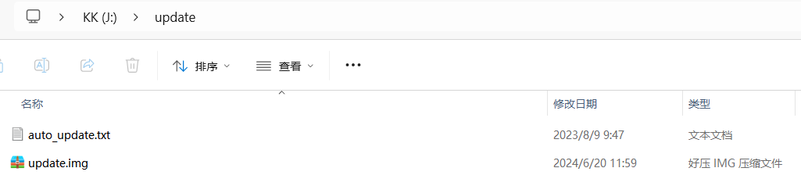
- The machine is not connected to the power cord. First insert the U disk into the USB port of the machine and then plug in the power cord (you do not need to press the machine’s power button).

Note: Machines with batteries need to press and hold the machine power button for 3-4S. For example: D042Q, D061, D048Q
In addition, you need to ensure that the machine has sufficient power and will not shut down due to insufficient power during the upgrade process.

- Wait for the machine to display a green upgrade progress bar as shown below, indicating that the machine has entered the upgrade state.
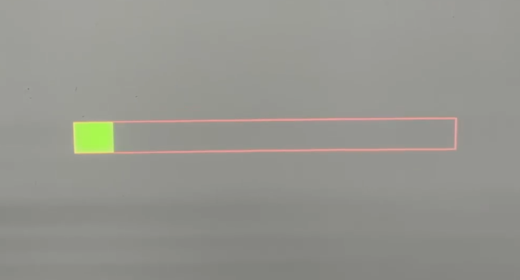

5. After the upgrade progress bar is full, re-plug the power cord of the machine and turn it on.
