PixaPlay 67 OTA Update Procedure

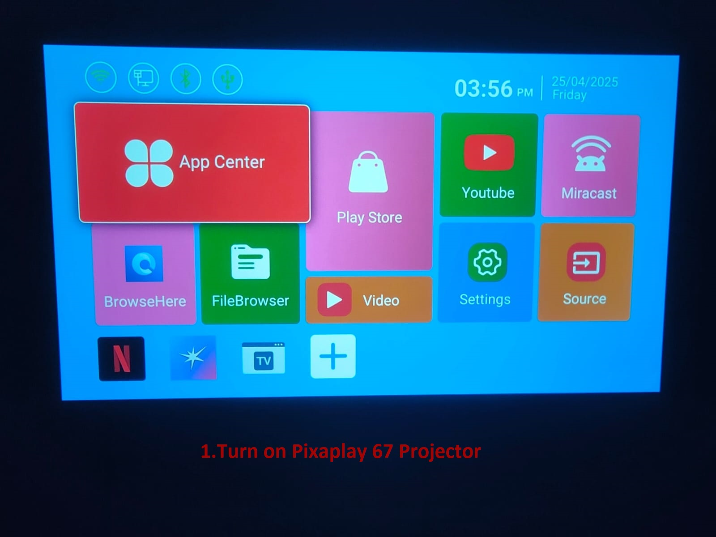

Step 1: Turn on the Pixaplay 67 Projector.

Step 2 : Copy the Local updater Apk to a pendrive andd install it to the projector

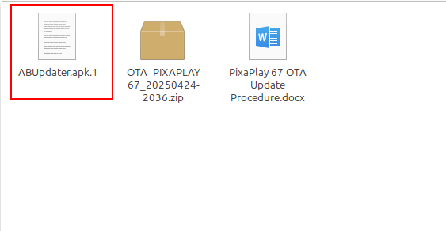

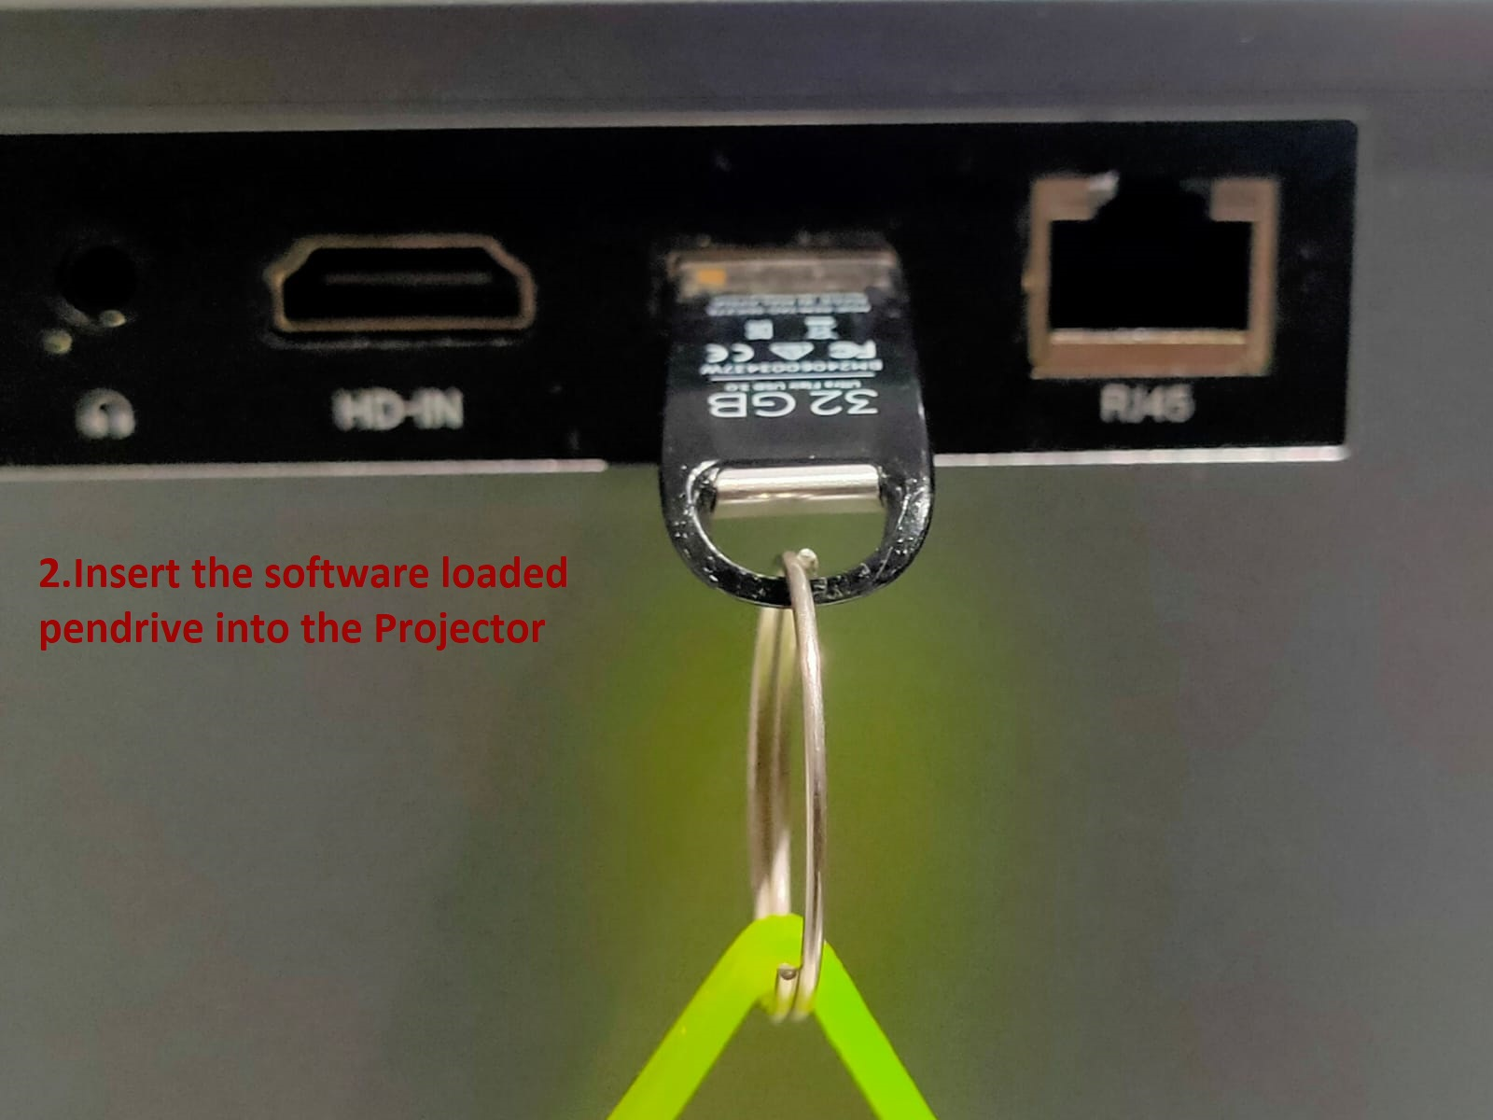

Step 3: Now Copy the Software file to a pendrive andd insert it to the Projector

Note:
1.Do not unzip or Extraxt the file (Software must be in zip format)
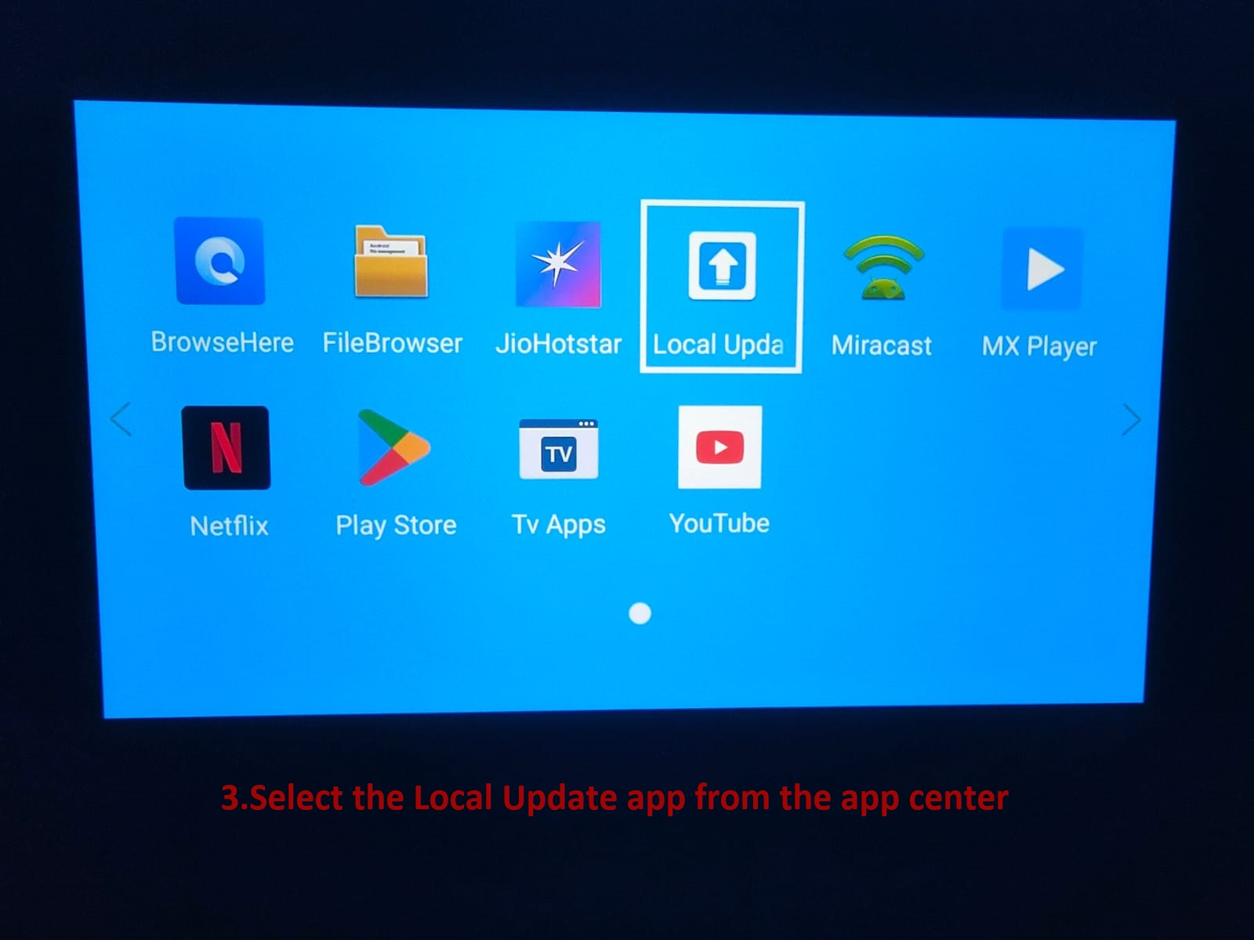

Step 4: Open the Local update app from App centre.

Note:
1.If this app is not available, Install the app with package installer.

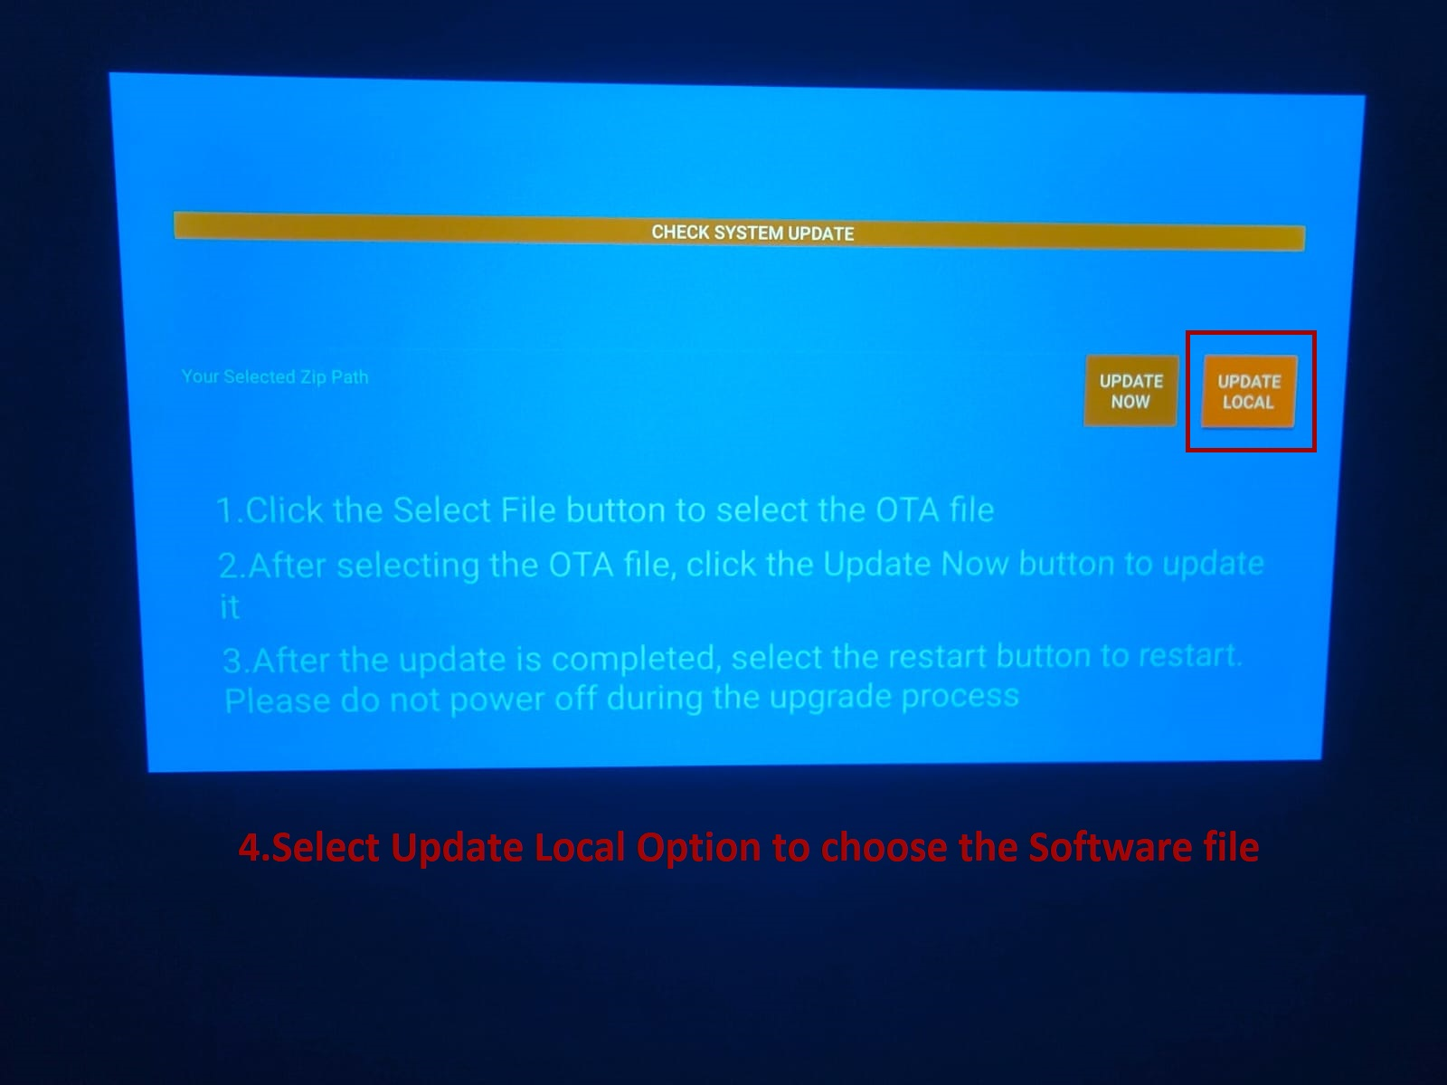

Step 5: Click on the Update local option
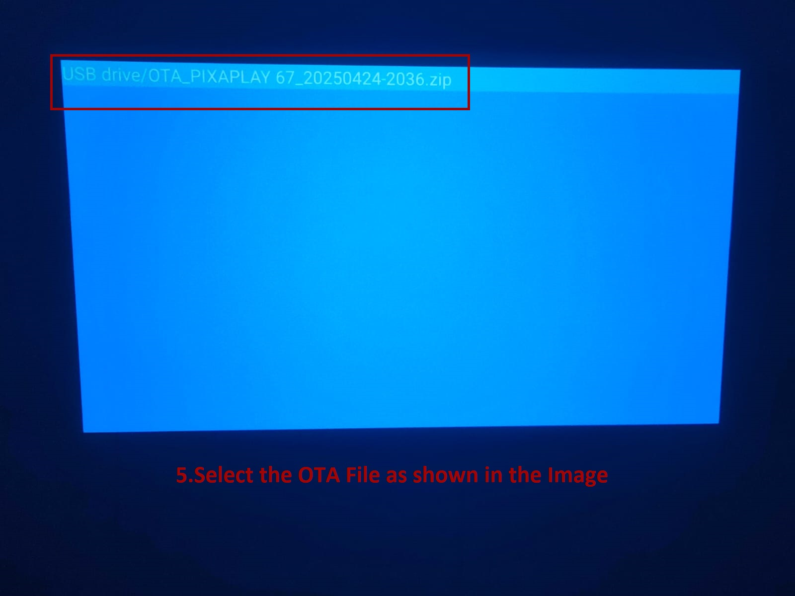

Step 6: Once choose the file it will shows in the updater app.
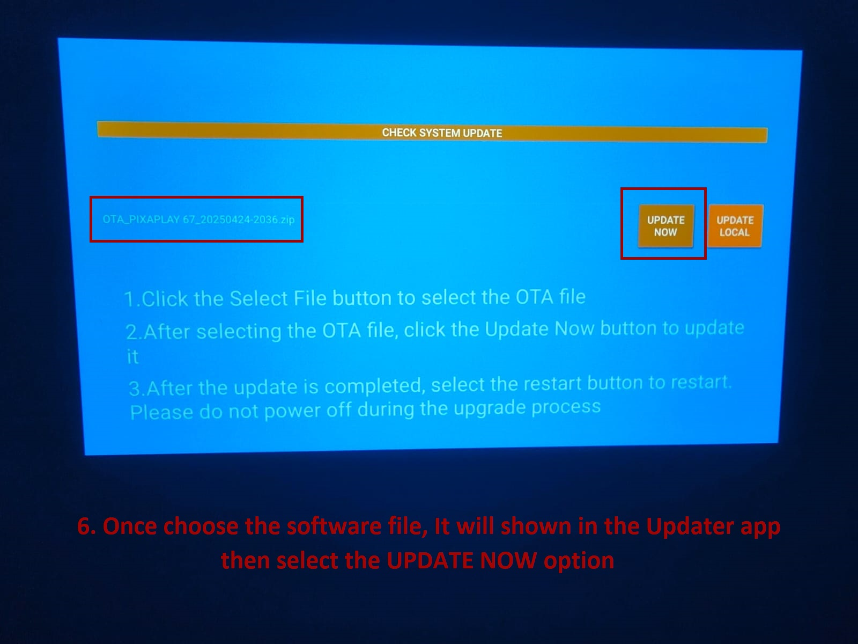
Step 7: Then, Select the Update Now Option.
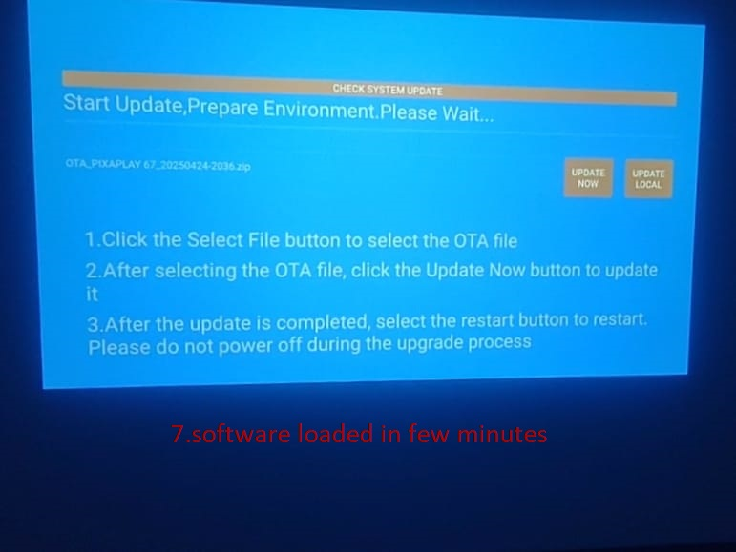
Step 8: Now the software will update in few minutes.
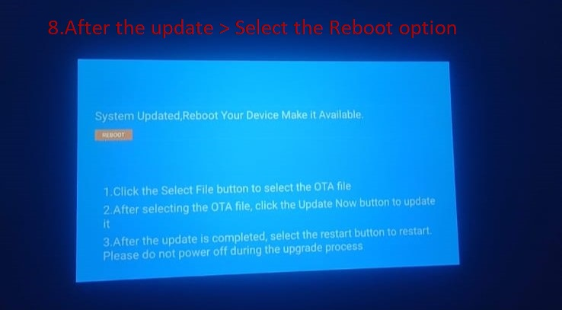
Step 8: After completion of the software select the reboot option.
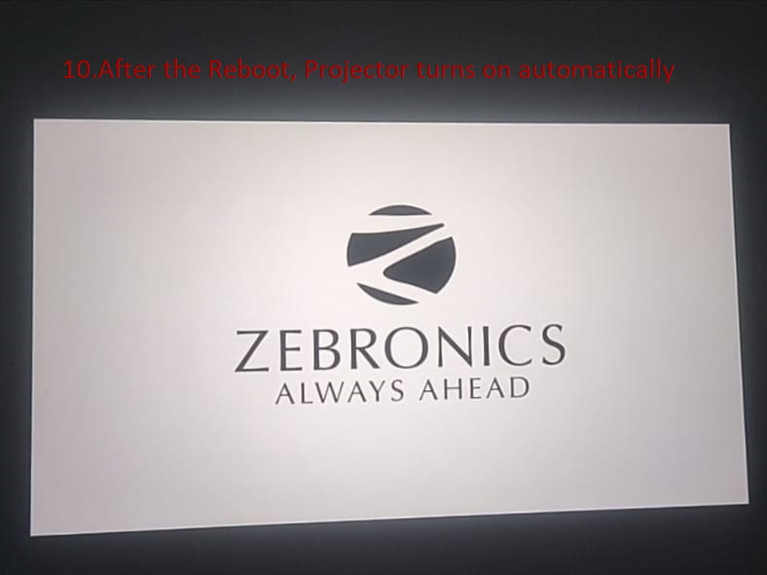
Step 9: Now it will Turn on automatically.
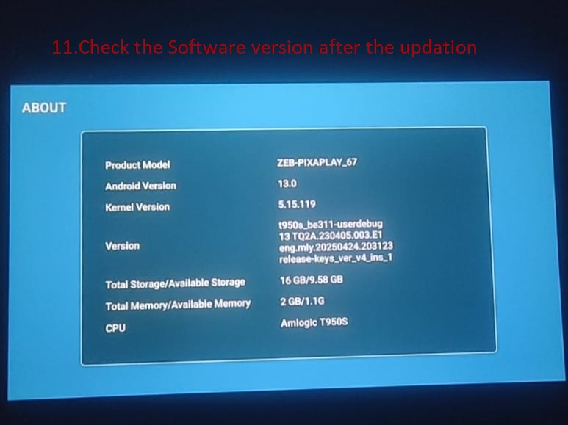
Step 10: Check the software version after the update.

