ZEB-Pixaplay Pro 500 upgrade instructions
Option one:
1.After networking, power on the computer, the prompt of update will pop up automatically, the user presses the “OK” button to enter the upgrade page.
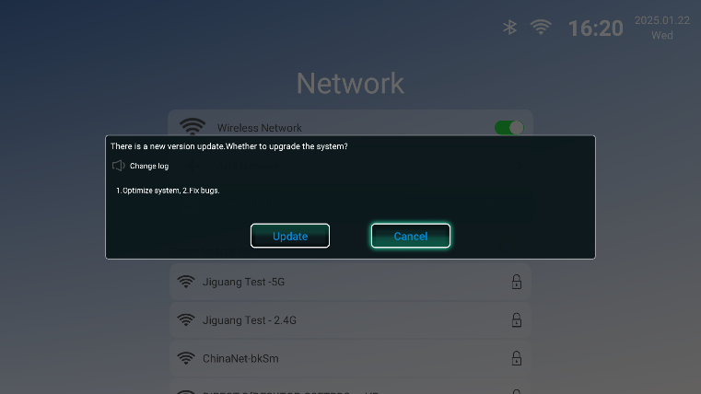
2.press the “OK” button, will enter the state of the DOWNLOAD software
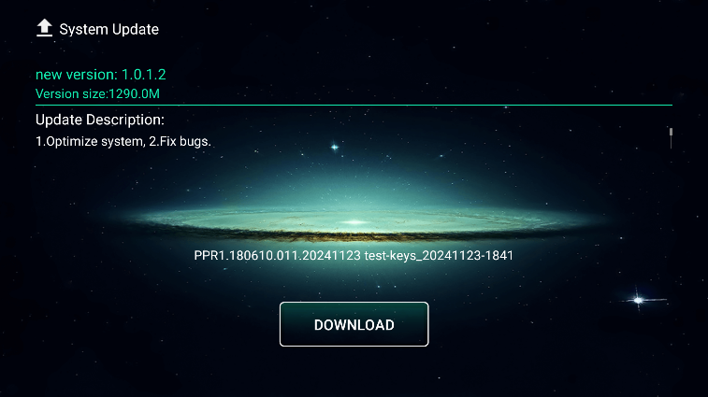
3.Press “OK” again to cancel DOWNLOAD.
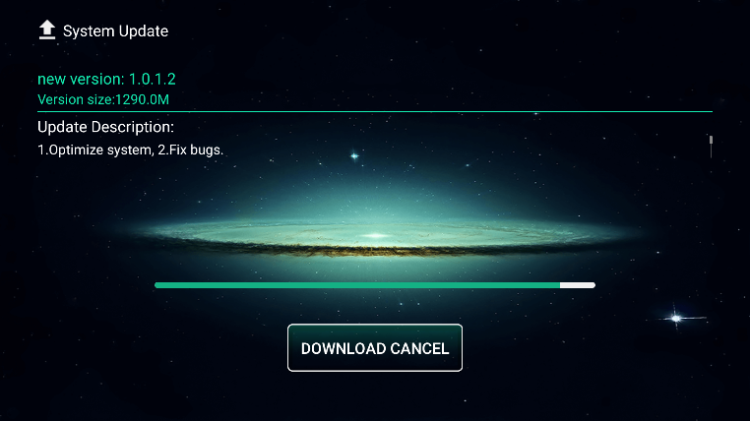
4.DOWNLOAD completed, it will display “CLICK UPDATE”, press the “OK” button to enter the upgrade state
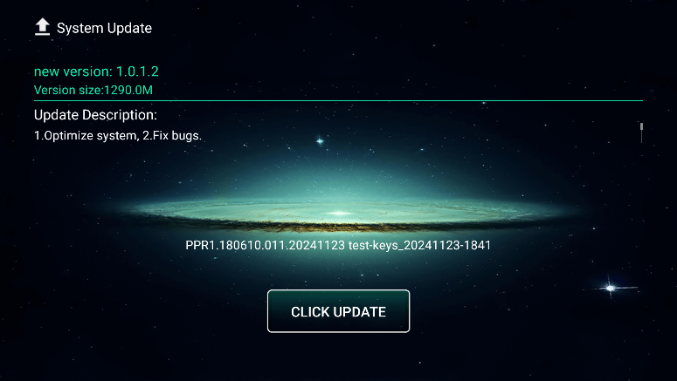
5.Upgrade process，DO NOT OPERATE THE DEVICE
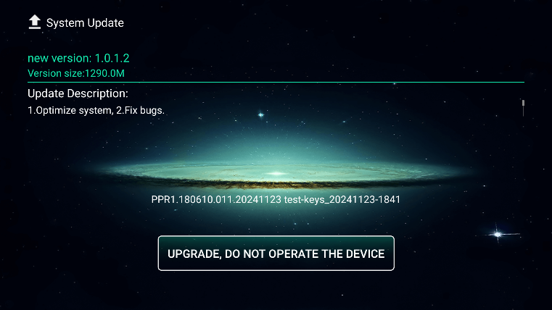
6.Please do not disconnect the power during the upgrade process!
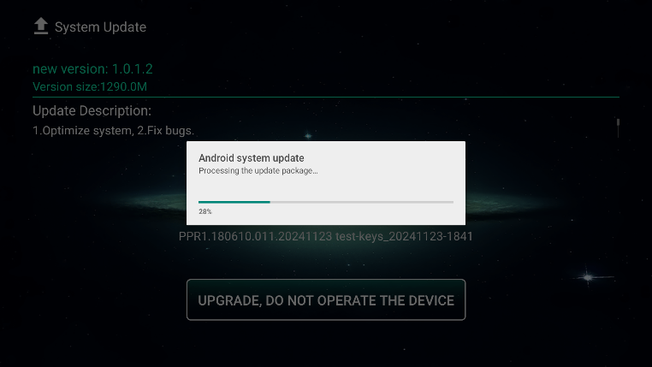

7.upgrade is complete, will enter the main page, the machine upgrade is complete!

Option two: Manually select online upgrade
1.Ensure that the network connection is normal
2.Select Update and enter
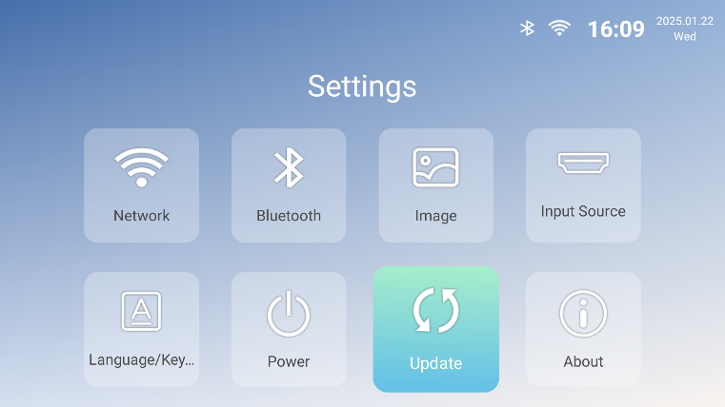

3.After entering, select Online Upgrade and enter
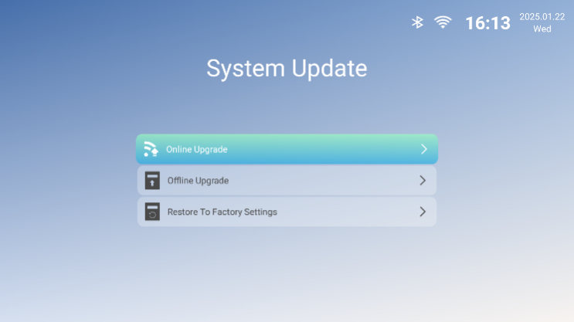

4.press the “OK” button, will enter the state of DOWNLOAD software!
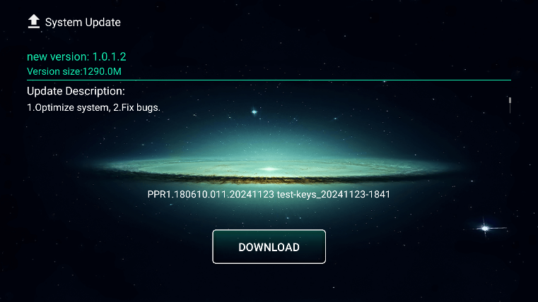

5.press the “OK” key to enter the DOWNLOAD software status, press the “OK” key again to cancel DOWNLOAD!

6.DOWNLOAD completed, it will display “CLICK UPDATE”, press the “OK” button to enter the upgrade upgrade state!
7.DO NOT OPERATE THE DEVICE during the upgrade process.

8.Please do not disconnect the power during the upgrade process!

9.the upgrade will be completed to the main page, the machine upgrade is complete!

The upgrade is complete and accessible:Setting – Update – System Update – Online Upgrade – Check Version
